Project Design Phase-II
Data Flow Diagram & User Stories

Date | 08-12-2025
Team ID
Project Name | Book store
Maximum Marks | 4 Marks

Data Flow Diagrams:
A Data Flow Diagram (DFD) illustrates how data moves within the Book store platform. It captures how users (Sellers and Buyers) interact with the system, how information flows between different components (like inventory and orders), and where the data is stored.
DFD Level 0 — Book store System (Context Mapping):
- Seller (formerly Client): Inputs book details into the system.
- User (formerly Buyer): Browses books, places orders, and manages their profile.
- Process 1 (User Authentication): Verifies credentials for both Sellers and Users.
- Process 2 (Add Books): Allows Sellers to post new books to the Books Database.
- Process 4 (User/Seller/Order Details): Manages communication and notification regarding order status.
- Process 5 (My Products and Orders): Allows Users to view their purchase history and Sellers to view their listed products.
- Databases:
  - Books Database: Stores book inventory.
  - Order Database: Stores active and past orders.
  - User Records: Stores user and their credentials.

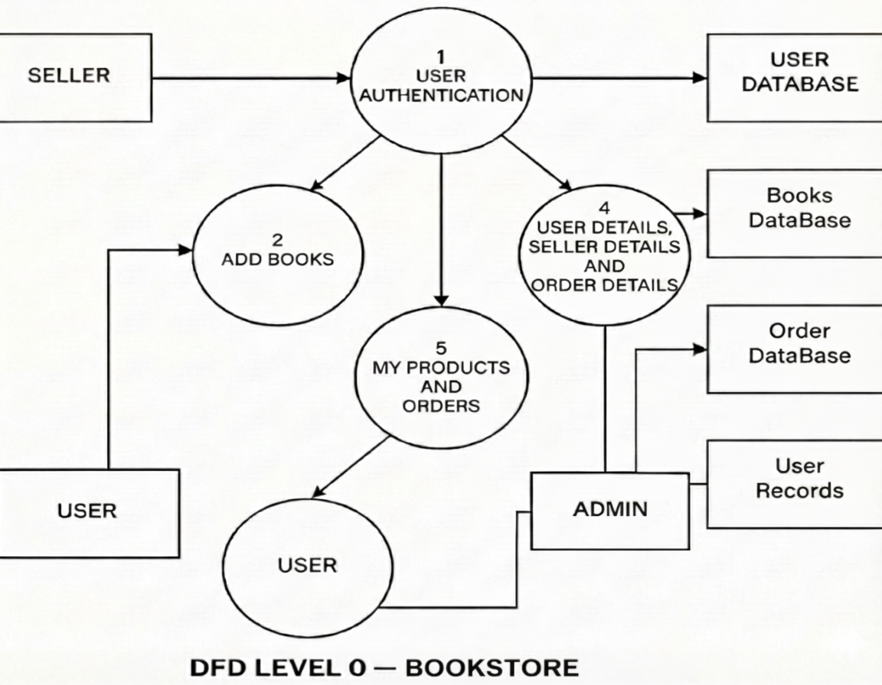

User Stories

User Story Table – Freelance Finder
User Type | Functional Requirement (Epic) | User Story / Task | Acceptance Criteria | Priority | Release
seller | Inventory Management (Add Books) | As a Seller, I can add a new book with details (Title, Price, Author). | Book appears on the homepage and in the "My Products" dashboard.. | High | Sprint-1
user | Searching Books | As a User, I can browse and filter available books | Filter returns relevant results. | Medium | Sprint-2
user | Purchasing (Order Placement) | As a User, I can add a book to my cart and place an order. | Order is recorded in the Order Database and visible to the Seller. | High | Sprint-1
User | Order Tracking (User Details) | As a User, I can view the details of my current and past orders. | Order status and details appear instantly in " Orders and My Orders ". | Medium | Sprint-2
Admin | Inventory Management | As a Admin, I can review and remove books updated by seller. | Changes are saved successfully. | High | Sprint-2
Admin | User/Seller Management | As an admin, I can review reported Sellers or Users and take action. | As an admin, I can review reported Sellers or Users and take action. | High | Sprint-1

